EXPERIMENT -6
SETP-1:
DOWNLOAD THE UMBERALLO AND OPEN IT
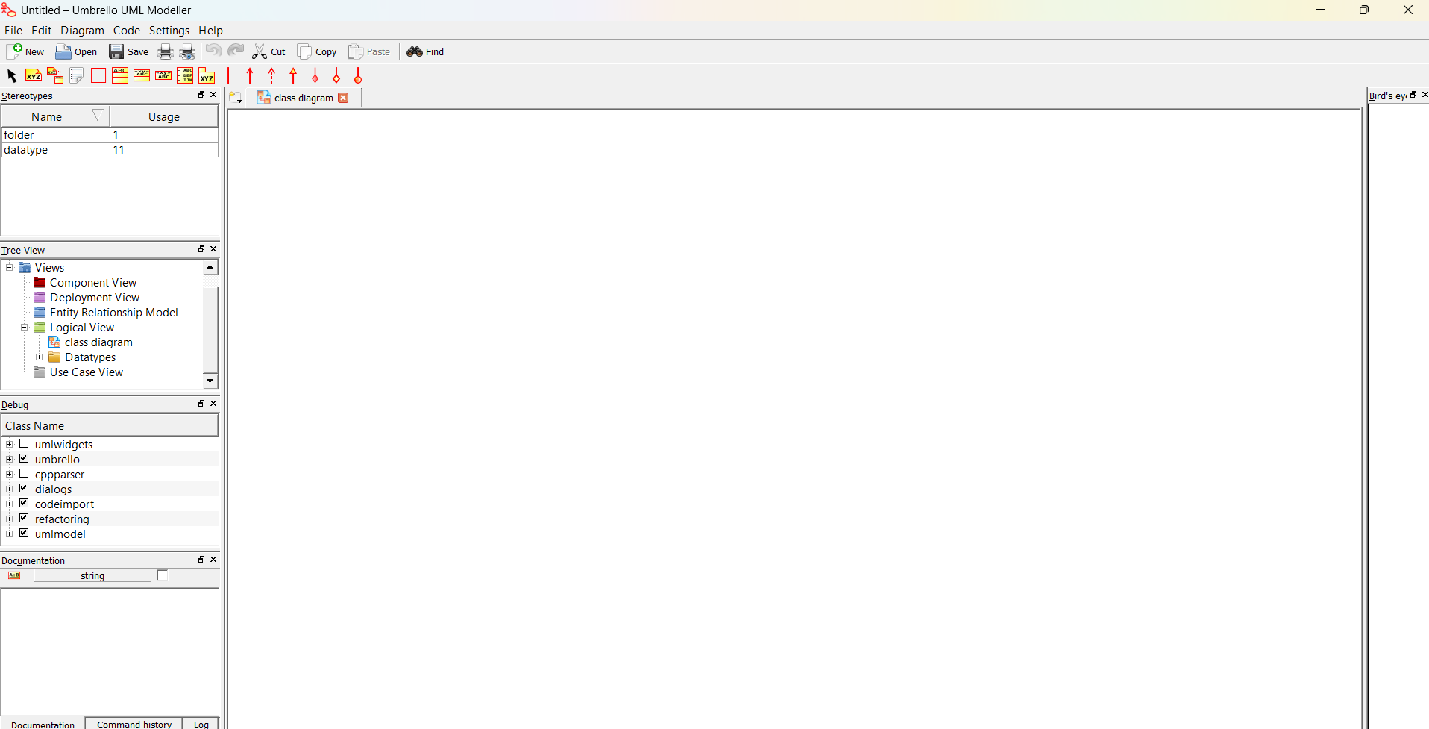

STEP 2:CREATE THE CLASSES WITH THESE NAMES
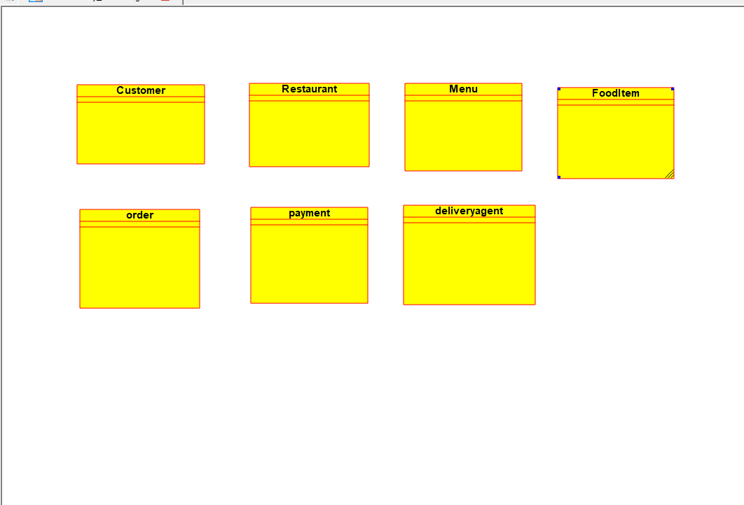
STEP3:-ADD THE ATTRIBUTES AND THE OPERATIONS
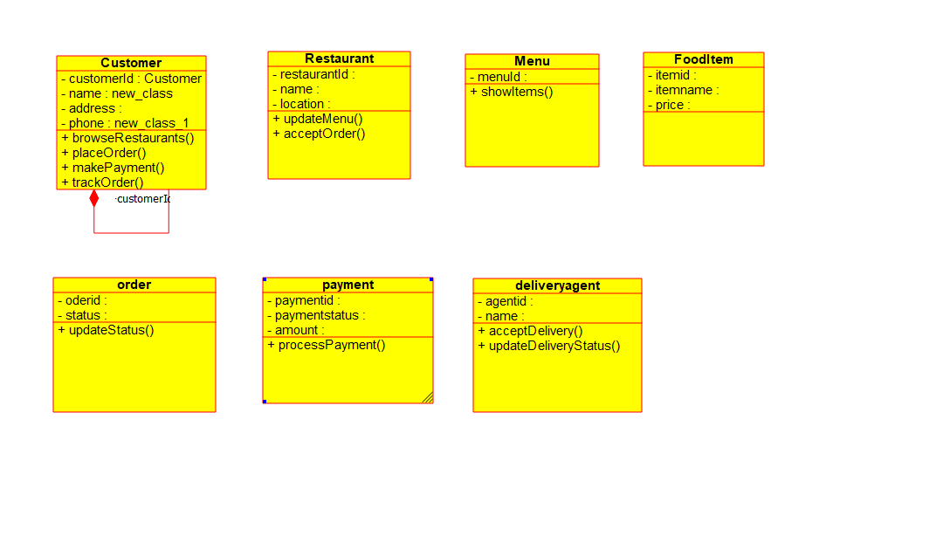
STEP4-CONNECT THE ASSOCIATION WIRES


